Rowan Ahmed Wally

<rowanwally1234@gmail.com>

Deploy Static Website on AWS  
Meets Specification

Website Files

The S3 bucket is created.

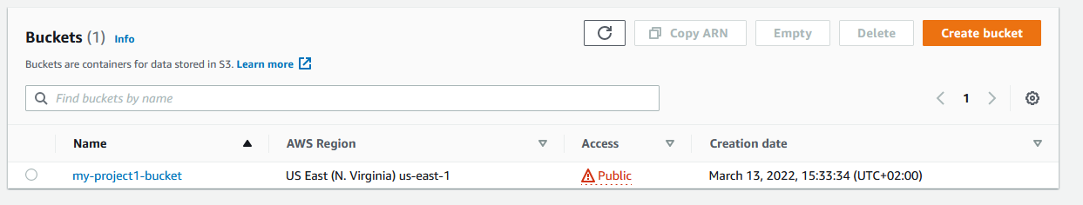

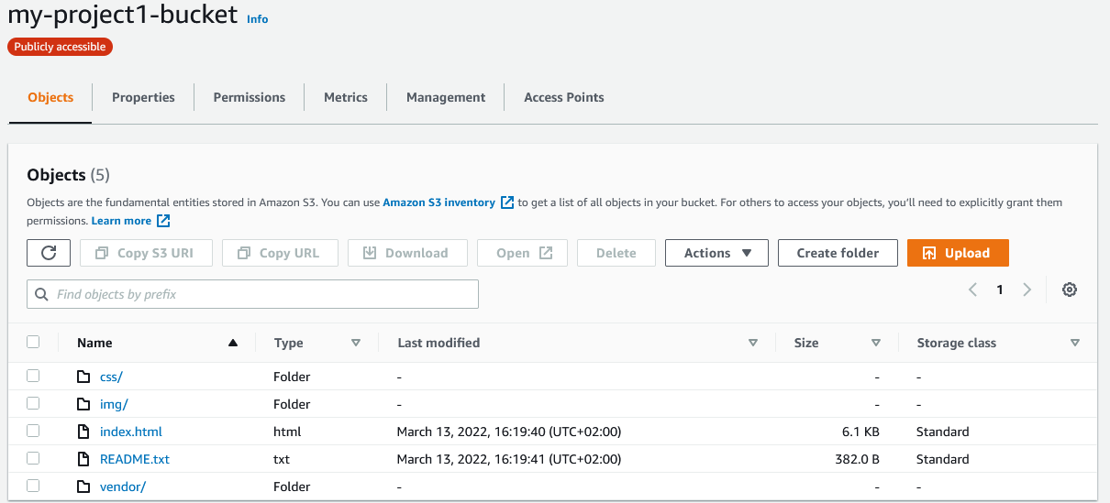

The S3 bucket is configured to support static website hosting.

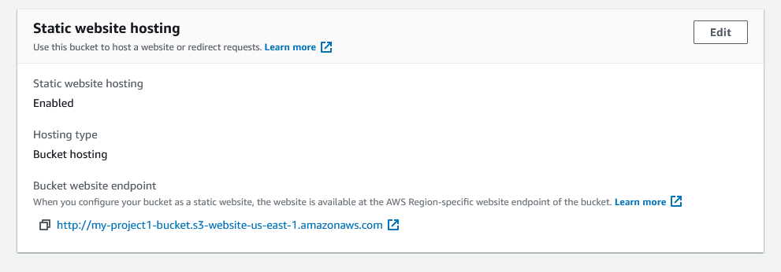

<http://my-project1-bucket.s3-website-us-east-1.amazonaws.com>

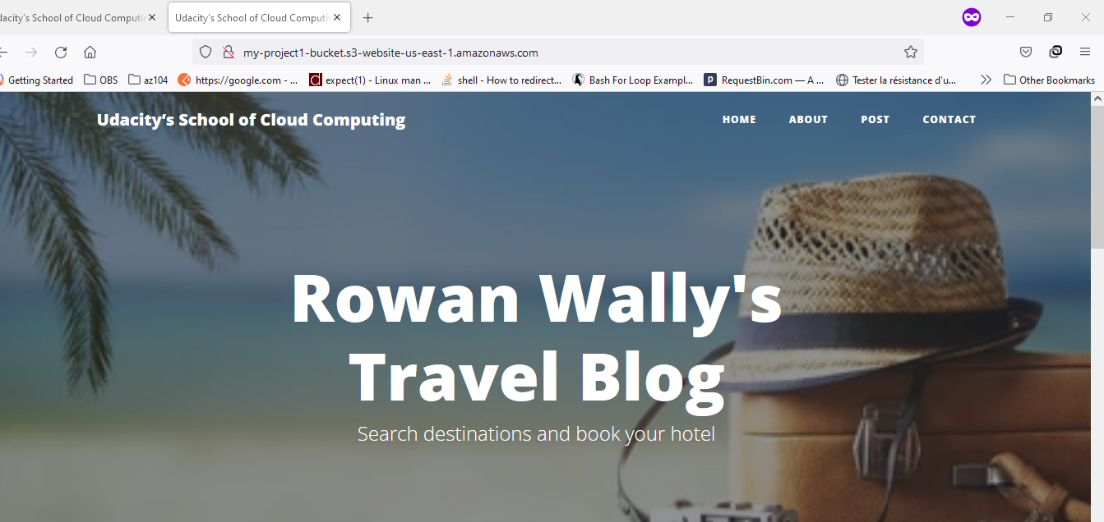

And the IAM bucket policy that makes the bucket contents publicly accessible

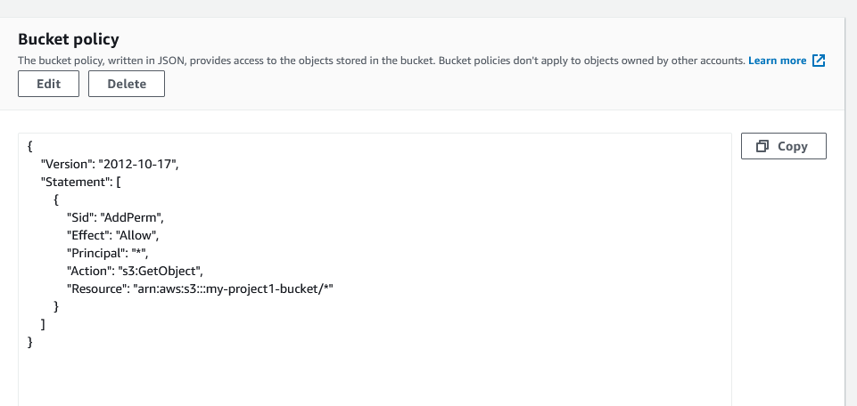

Website Distribution

CloudFront has been configured to be to retrieve and distribute website files.

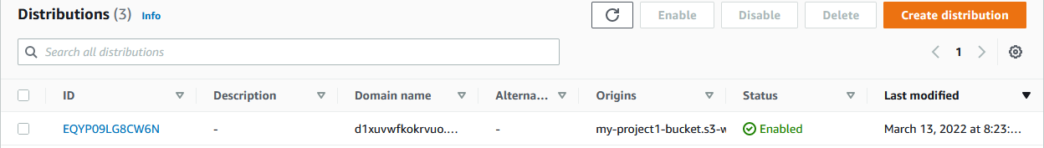

Web Browser Access

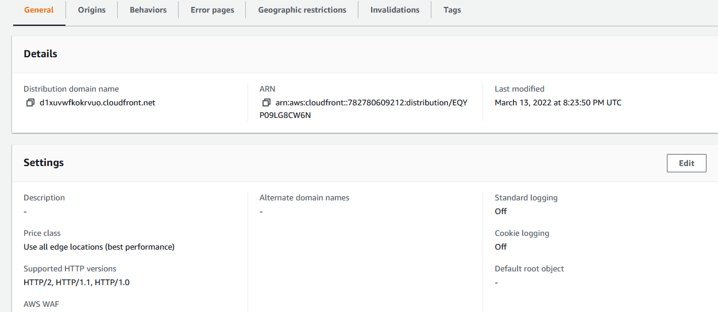

d1xuvwfkokrvuo.cloudfront.net/

